How Much Does It Cost to Become PRINCE2 Certified?



<https://www.study365.co.uk/wp-content/uploads/2023/09/prince2-certification-cost.png>

*Ready to take your career to new heights? Ready to Invest in Your Future? Wonder how much a valid certification in project management will cost? Then this article is just for you.*

**Let's talk about how much it costs to get a PRINCE2 certification.** The [PRINCE2](https://en.wikipedia.org/wiki/PRINCE2) (Projects IN Controlled Environments 2) certification is a special qualification that project managers can get to make themselves better at their job and have more opportunities for their future careers.

Just like any certification, there are costs that candidates need to think about. The amount of money you have to pay for these things can change depending on different stuff like:

* How much training you have
* Where you live
* Who you're getting trained by
* How much the exam fees

In this talk, we'll talk about the usual things that make the PRINCE2 certification cost money and give you an idea of what to expect if you want to get this certification.

## 6 Reasons Why PRINCE2 is extremely popular in project management?

1. **Universal Applicability:** PRINCE2 can be used in lots of different industries, like healthcare or technology, and for different kinds of projects. This makes it a flexible way of doing things that can work for lots of different situations.
2. **Structured Approach:** The structured approach is a way of doing things that has clear steps and people in charge. This helps make sure projects are done right and everyone knows what to do. It also helps keep things organised and under control.
3. **Global recognition:** PRINCE2 is known all around the world and lots of people agree that it's a good thing. If you become certified in PRINCE2, it can help you get better jobs as a project manager.
4. **Risk management** is a way of dealing with problems before they happen. It helps organisations find and fix issues before they become big problems. This makes projects more likely to succeed.
5. **Business Focus:** PRINCE2 makes sure that projects make sense for the business and help achieve important goals. It's all about making sure the organisation gets something valuable out of the projects.
6. **Lessons learned:** The idea of continuous improvement means that organisations should learn from what they've done in the past and use that knowledge to do better in the future. This helps create a culture where people are always learning and growing.

Understanding PRINCE2 Certification

There are different levels of PRINCE2 certification. They are made for people with different levels of knowledge and jobs in project management. The main certification levels are:

* [**PRINCE2® Foundation:**](https://www.study365.co.uk/course/prince2foundation/) This is the first level and helps you learn the basic ideas and words used in the PRINCE2 way of doing things. It's a good starting point for people who are new to PRINCE2.
* [**PRINCE2® Practitioner**](https://www.study365.co.uk/course/prince2practitioner/)After you've learned the basics in the Foundation level, the Practitioner level goes into more detail about how to use PRINCE2 principles, processes, and themes. Candidates have to show that they can use the methodology in real-life projects.
* [**PRINCE2 Agile® Practitioner**](https://www.study365.co.uk/course/prince2-agile-practitioner-course-with-official-exam/)This level mixes PRINCE2 with agile practises. It's for people who work in places where they need to be flexible and quickly adapt to changes. This helps people learn how to use PRINCE2 with agile methods in a good way.

Importance of understanding the full cost of certification.

It's really important to know how much certification will cost because then you can make smart choices. If you want to plan your money well, it's important to know how much everything will cost. This includes things like:

* Training
* Fees for exams
* Materials
* Travel expenses

Being aware of this helps you avoid surprise money problems and makes sure you can focus on getting certified. This way, you make the most of your investment in your career and get better at your job.

Cost of PRINCE2 Certification

Becoming professionally certified is more than a commitment of time and effort; it's a financial journey too.

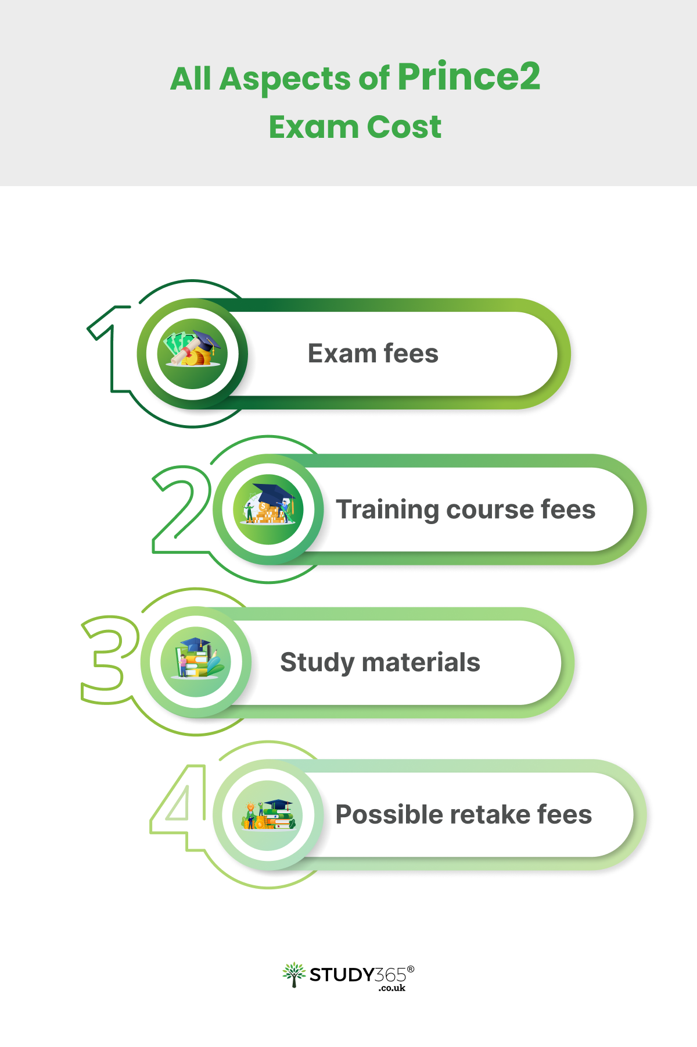

https://www.study365.co.uk/wp-content/uploads/2023/09/prince2-exam-cost.png

Proper planning and budgeting are crucial. They not only help manage expenses but also set you up for exam success.

Ready for the challenge? Enrol in a PRINCE2 Certification course now!

Breakdown of PRINCE2 Certification Costs

Let's have a closer look at the different costs that come with getting PRINCE2 certification:

1. Exam fees
2. Training course fees
3. Study materials
4. Possible retake fees

Let’s elaborate the above facts:

### Exam fees

Exam fees are really important when you want to get certified. They include all the costs for taking the certification exam. The amount of money you have to pay for these fees can change depending on how advanced your certification is.

* the way the exam is set up
* where you take the test
* the place where you go to take it.

It's really important for students to know about exam fees so they can plan their money properly. So, thus the learner will not get any unexpected money problems right before the exam. It makes sure that people have enough money to finish their certification and get the credential they want. This helps them grow professionally and achieve their career goals.

1. Training course fees

Training course fees are the money you have to pay when you sign up for and take part in a certification training programme. These fees are for:

* paying the teachers
* buying the stuff you need for class
* sometimes getting extra practise tests

The exact price can change depending on things like:

* How advanced the certification is
* Where you get the training
* Where you are
* How long the course takes

It's really important for people to know how much training courses cost. This helps them decide if it's worth the money, pick the right course, and plan how much they need to save up for their certification.

1. Study materials

### 

Study materials are things that:

* Schools
* Universities
* [Online Course Providers](https://www.study365.co.uk/contact-us/)
* Teachers
* Lecturers
* Tutors
* Groups

give you to help you learn and do research.

These things are all the stuff that helps students learn in school or university level. They include:

* books
* schedules
* instructional aids
* things that help with teaching
* extra info to help students do well in their classes.

They help you understand things better, make sure you remember what you learn, and help you study in a good way. This all helps you do well in school and be successful.

1. Possible retake fees

Possible retake fees refer to the costs associated with retaking a certification exam in case a candidate does not pass on their first attempt. These fees vary depending on the certification body, exam level, and policies in place. Understanding possible retake fees is important for candidates to plan for potential setbacks and allocate resources accordingly. It underscores the significance of thorough preparation and minimizes financial surprises in the event of needing a second attempt to achieve certification.

Hidden Costs of PRINCE2 Certification

When you want to get PRINCE2 certification, you have to pay for training and exams. But there are also other costs that you might not think about at first. These include the big amount of time you need to spend studying and getting ready for exams. Also, if candidates choose to take exams or do training in person, they might have to pay for travel and a place to stay.

It's really important to know about these hidden costs when you're making a budget and planning for your PRINCE2 certification. This way, you can be ready with enough money and time for the whole journey.

## Total Cost of PRINCE2 Certification

The total cost of the PRINCE2 certification includes both visible and hidden costs. The total amount of money you need to spend to get PRINCE2 certification includes different things. Basically, there are fees for training courses. The fees can be different depending on the level of certification you want and where you are located.

The fees for exams are not the same for every level of certification. This means that the costs can vary depending on which level you are aiming for.

The stuff you use to study, like books and other resources, can also help you learn. Also, if candidates choose to do training or exams in person, they might have to pay for travel and a place to stay.

**By attending** [**study365 full package**](https://www.study365.co.uk/course/prince2-complete-training-and-exams-package/) **you can definitely save up some money.** It’s extremely beneficial from a monetary point of view.

Is PRINCE2 Certification Worth the Cost?



https://www.study365.co.uk/wp-content/uploads/2023/09/prince2-certification-worth-the-cost.png

Getting a PRINCE2 certification can be really helpful and worth it, even though it might cost you some money. It helps you get better at managing projects, makes it easier to find a job, and lets you work in different industries all around the world. When professionals become certified, they learn a structured way to manage projects. This helps them increase the chances of their projects being successful. Getting PRINCE2 certification is a really good idea because it can:

* help you get better job opportunities
* move up in your career
* be really good at leading projects

It's definitely worth the effort!

Summing up

In simple terms, when you want to get PRINCE2 certified, you have to pay for the:

* Training
* Exams
* Any additional things that might come up

The certification is really important because it helps you become:

* Better at managing projects
* Gives you more job options
* Helps you do projects well

Before making a decision, think about what you want to do for a job and consider your own personal situation. When you make a smart choice, it can really help your career and how you manage projects.

PRINCE2 Certification is one of the most valued project management courses in the UK but is followed up all over the world. In Study365 we provide you the option of paying in full or paying in monthly instalments. It’s for your own convenience. Get Started with [PRINCE2.](https://www.study365.co.uk/course/prince2foundation/)

**Recommended images**

FAQs

1. Are PRINCE2® training courses accredited?

Yes, PRINCE2® courses are accredited by [PeopleCert,](https://www.peoplecert.org/browse-certifications/project-programme-and-portfolio-management/PRINCE2-2) on behalf of [AXELOS.](https://www.axelos.com/certifications/propath/prince2-project-management)

1. How long does it take to get PRINCE2 certified?

The amount of time it takes to become PRINCE2 certified can be different for each person. Getting a foundation certification usually requires a few days of training and studying than the practitioner. After completing the Foundation level, practitioners will need to spend more time studying. How long it takes you to finish something can depend on a few things. These include:

* how much you've done before
* how quickly you work
* how often you can practise or train

1. Is a PRINCE2 qualification worth it?

PRINCE2 qualification is a world-renowned brand offering project management courses. It definitely worth the cost. The PRINCE2 method is a way to manage projects that is organised and can be changed to fit different situations and problems. It's a useful thing for project managers in any job.

1. Can I self-study for PRINCE2 certification?

If you want to learn on your own, that's okay, but it's really a good idea to take official classes to make sure you understand everything and do well on the exams.

1. How can PRINCE2 certification benefit my career?

Getting a PRINCE2 certification helps you become a better project manager. Learning new skills can help you explore different jobs and make it easier to find work. It can also help you move up in your career and get better opportunities.